EXPERIMENT 1

ROLL NO: 240701148 NAME: Gokul S

USER INTERFACE AND DESIGN COMPARISON OF UI DESIGN BETWEEN TWO FIGMA CREATION

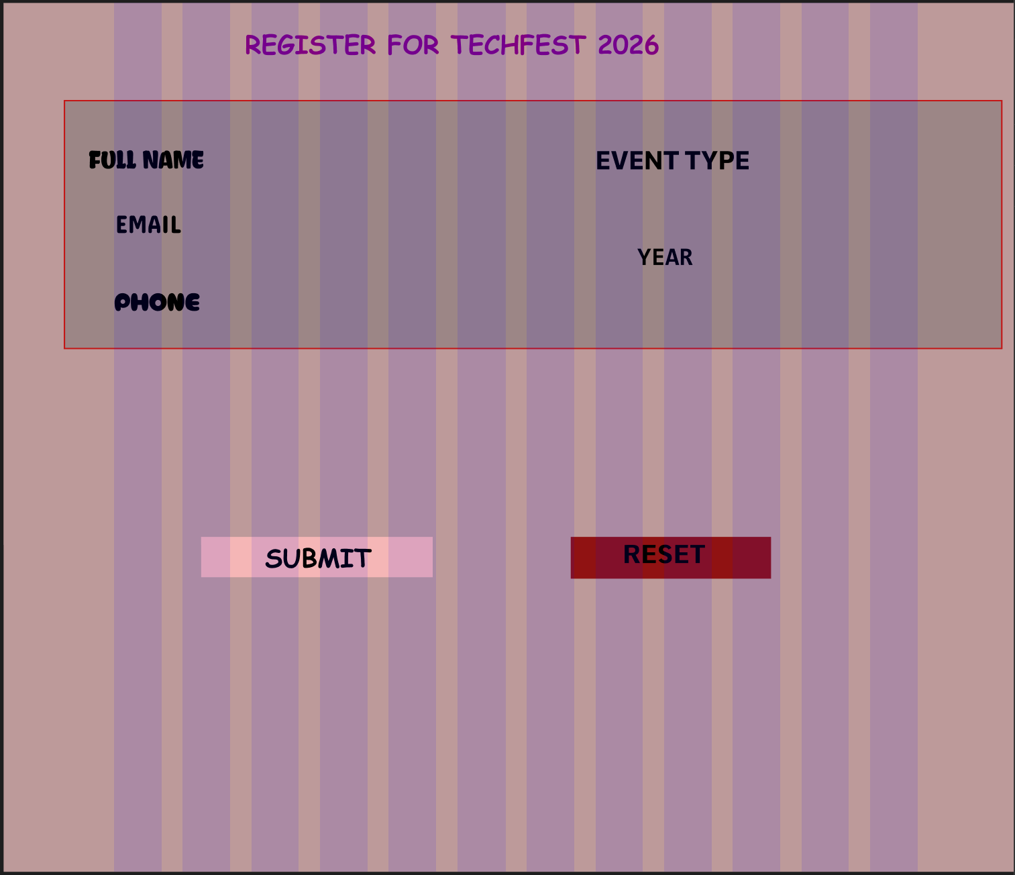
BAD DESIGN

GOOD DESIGN
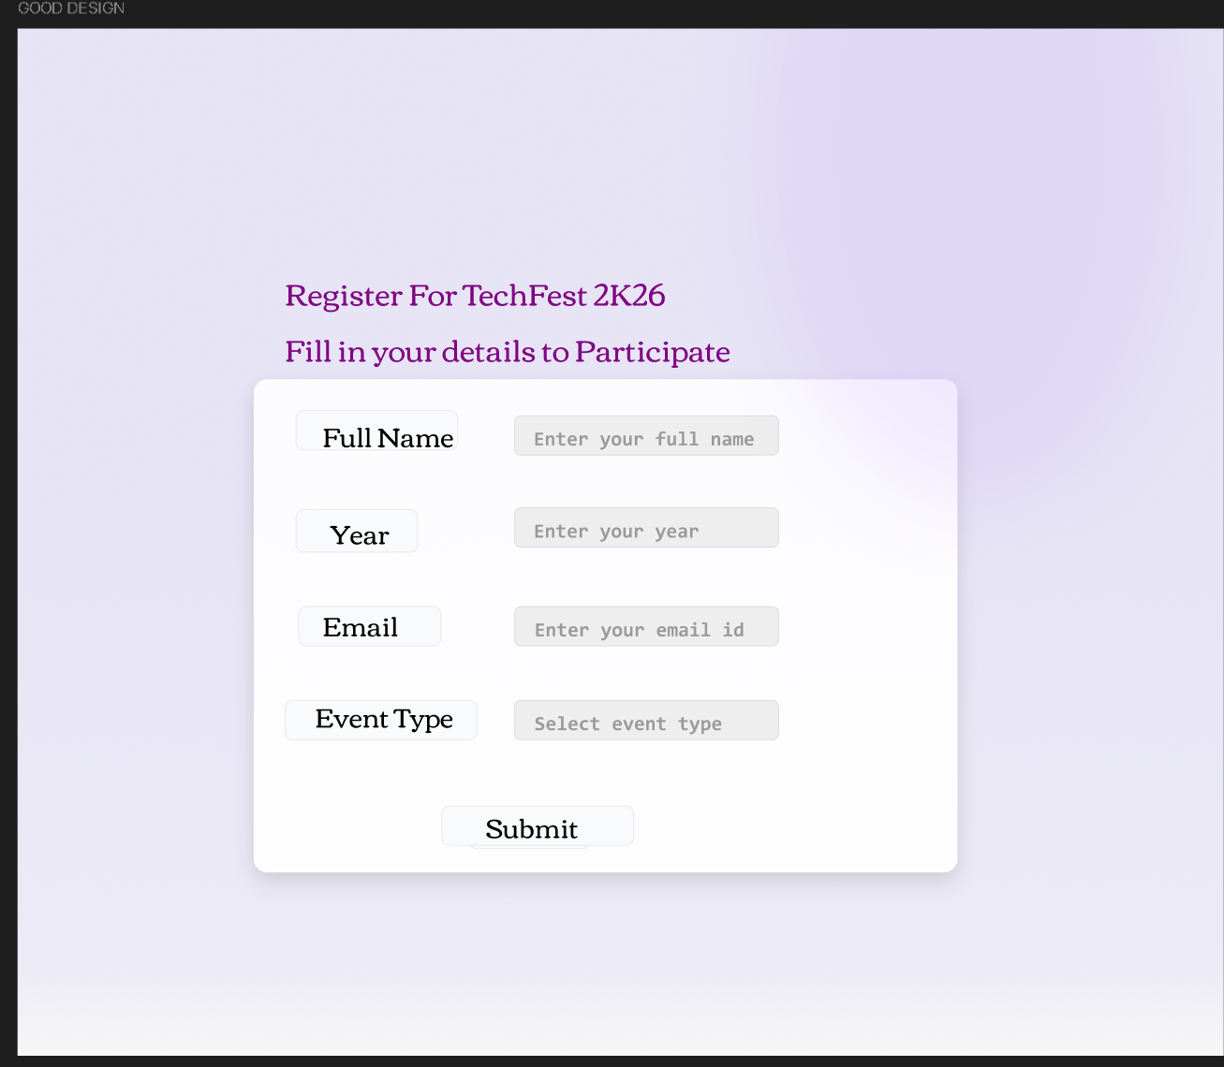

BAD DESIGN:
- Too many vertical stripes
- Hard to focus on form
- Reduces readability
- Only labels are shown
- Left side fields and right side fields are not balanced

GOOD DESIGN:
- Soft gradient background
- Not distracting
- Form is properly centered
- Balanced spacing on all sides
- Labels and input fields aligned neatly

